1. Log in Screen

How to Log in to myPortal

The purchasing element of PS Financials is located in a web-based portal called myPortal.

Where do I Log in?

(myPortal is only accessible through Internet Explorer. Internet browsers such as Chrome and Firefox will not work)

The schools should log in to myPortal through Internet Explorer via the link, see below;

- Brotherton and Byram Primary Academy https://eaaremote.vitalcloud.co.uk:444/myportal
- Ebor Academy Filey https://eaaremote.vitalcloud.co.uk:444/myportal
- Robert Wilkinson Primary Academy http://finance/myportal
- Haxby Road Academy http://finance/myportal
- Ebor Academy Trust http://finance/myportal

Should either of the web links above not work, please copy and paste the website address into the URL in your web browser as shown below.

Copy and paste the website address here, then press return
Log in Screen

Enter your Username and Password as shown below;

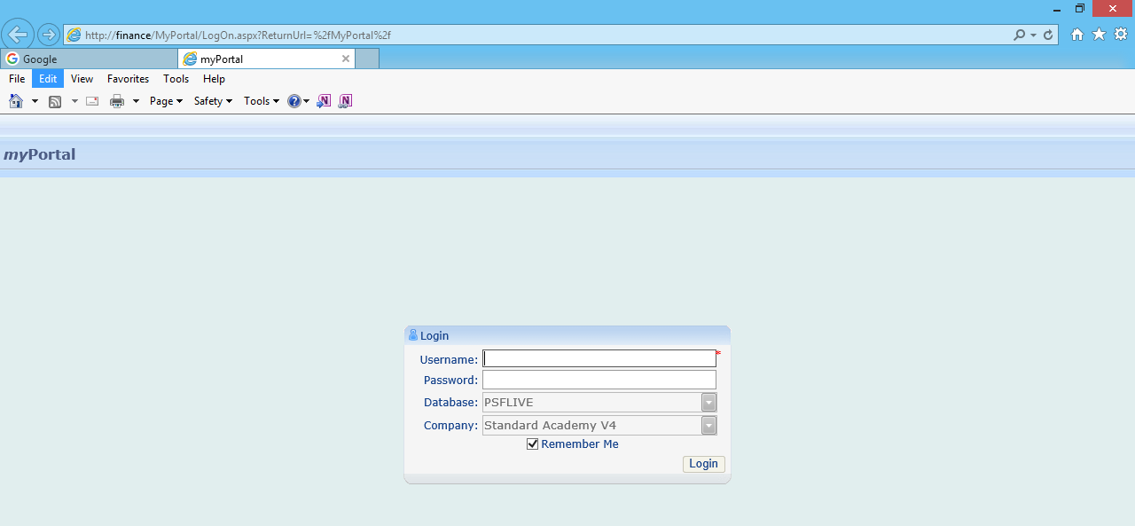
Enter your Username here
Enter your Password here

If required, using the dropdown list, select PSLIVE
Log in Problems or Questions

If you do not have login details (user name and password) and it is a requirement of your job role, you encounter any problems logging into the system, or you have forgotten your login details please contact Ebor Finance department, Tel no. 01904 553404 or via email finance@ebor.academy

