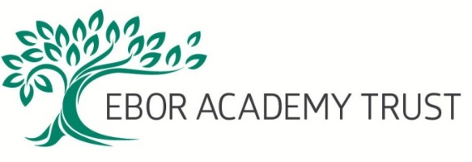

Performance Review for support staff – what it is and how to prepare

All staff at Ebor Academy Trust receive an annual performance review. This is a chance for each member of staff to meet with their line manager (or in some cases, a nominated other) to talk about their achievements over the year, receive feedback on their objectives and discuss their aspirations and work for the following year. Although it is a professional, recorded discussion, the tone of the appraisal should be as informal and positive as possible.

The aims of the performance review process are:
- To review your performance over the period in question, in particular assessing whether or not you have achieved the previous objectives set.

- To discuss the training and development you have had over the period in question and how it has benefitted you and your work for the Trust.

- To discuss wider issues about your role, any concerns you may have and any suggestions you may have about how improvements could be made.

- To agree objectives for the following year. These should always be SMART – specific, measurable, achievable, relevant and timebound. That way what is to be achieved should be clear to you and both you and your reviewer will know whether or not the objective has been achieved.

- To discuss what additional training, development, resources or other support you might need to be able to achieve your objectives.

- To check whether your job description still accurately reflects your role, or needs changing.

- If you would like to, to discuss your career development aspirations.
You will be given at least a week’s notice of your performance review. The meeting will take place in an appropriate, private place, free from interruptions. The meeting should be an honest and open discussion and is not an opportunity for your line manager to present serious concerns about your performance; if there are such concerns these should have been discussed with you in a separate meeting specifically for that purpose.

The content of your discussion will be summarised on a form which will be given to you after the meeting.

You will get the most out of your performance review if you prepare in advance. The meeting is a great opportunity to talk about your thoughts with your line manager and get feedback on your performance. To help you to prepare, you may wish to reflect on the following questions alongside considering the objectives set for the period in question:

- What do you consider to have been your strengths over the past year?
- What do you feel you have done particularly well – what are you most proud of?
- Is there anything that you feel in hindsight that you could have done better or differently? This might be how you did something or something personal to you, such as your attitude or timekeeping.
- Are there any barriers to you performing well in your role?
- Where do you feel you have a development need and how might this need be met?
- Are you happy with the support you receive from your line manager and colleagues – could anything be improved?
- Do you have any ideas for improvement for the work or operation of the Trust generally?
- How do you see your career developing over the next year or longer and how could this be met in the Trust?
- Is there anything else you would like to mention as part of your appraisal?

You don’t have to share any thoughts in advance with the individual conducting your performance review.

A copy of the blank Performance Review form is available on the website and if you would like any more information about the process, please feel free to talk to your line manager or a member of the HR team.

