Purchasing Document Created 21/02/2019

How to Produce a Goods Received Note Version 6.1

Step 1. Select Goods Received
Step 2. Search for the Supplier the Purchase Order was placed with
Step 3. Then Select the Supplier you want to raise a Goods Receive Note for.
Step 4. Enter the Purchase Order Number
Step 5. Select the lines to be Goods Received.
Step 6. Change any quantities that need changing on the Goods Received Note
Step 7. Review Order Details and Post Document
Step 8. Goods Received Note complete

Step 1. Select Goods Received. To do this hover over the Purchasing button;

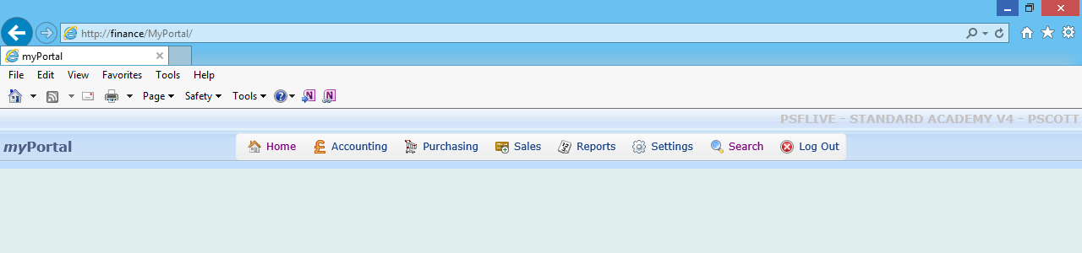
Purchasing button

This dropdown box will appear, then click on Goods Received;

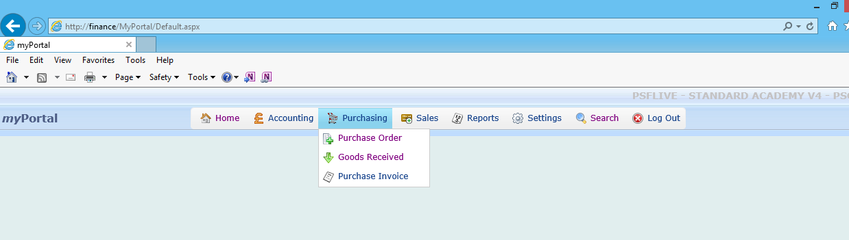
Goods Received

Step 2. Search for the Supplier the Purchase Order was placed with.
This Select Document box will appear. Click on Select Account to be taken to a Search Supplier screen;
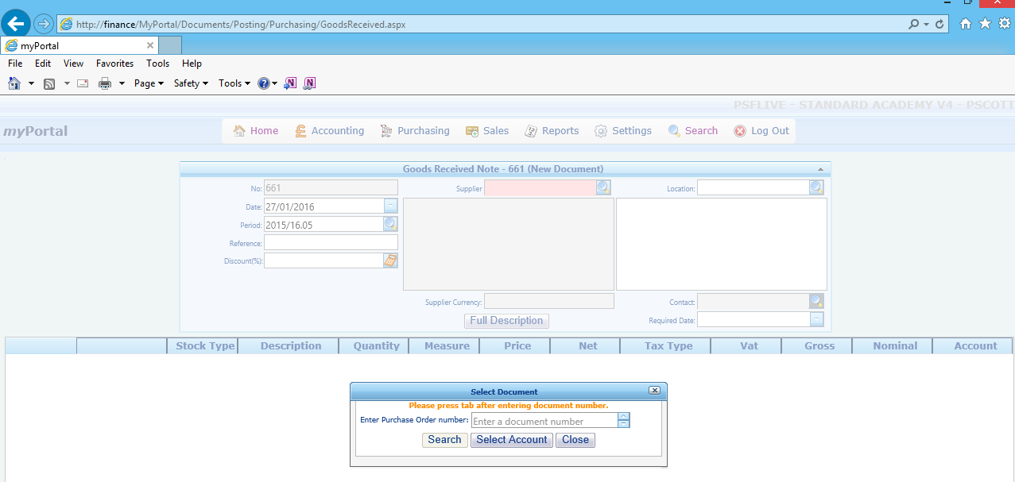
Select Account

The Search Supplier screen will appear automatically, as shown below;
Entering “YPO” in the Supplier box and pressing the spyglass , will bring up all suppliers with a Supplier Account Code starting with YPO.

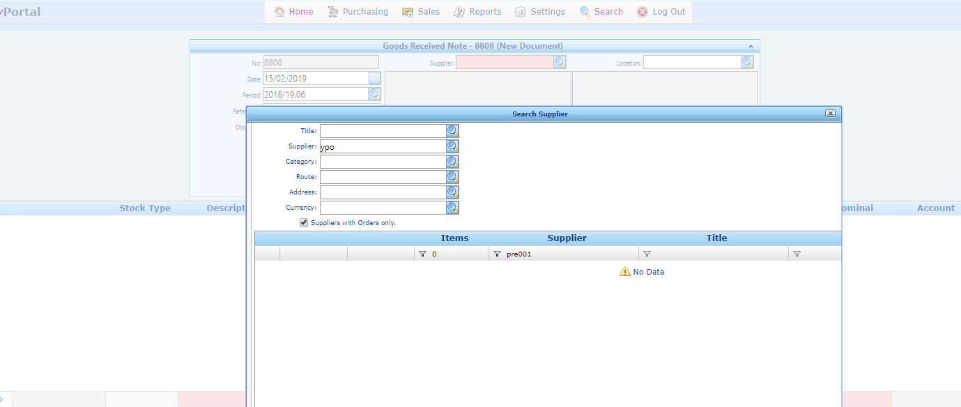
Enter YPO in Supplier then select the spygalss

Step 3. Then Press Select against the Supplier you want to raise a Goods Receive Note for;

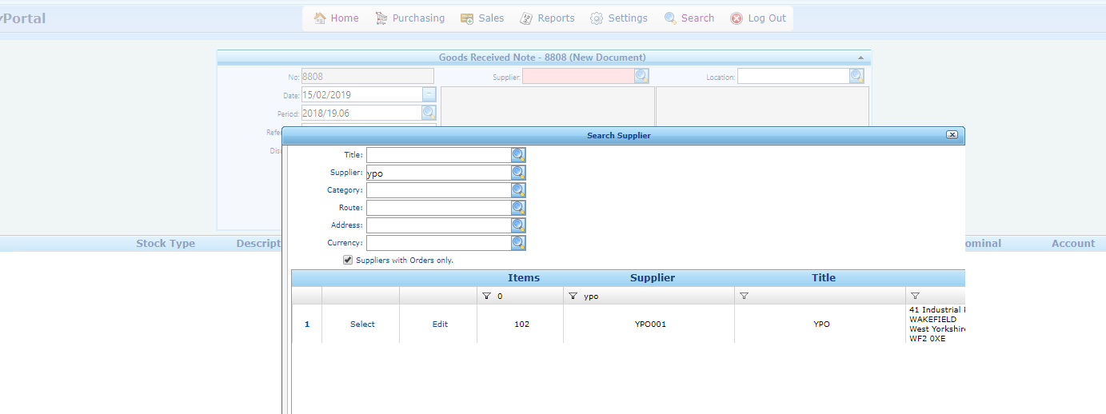
Then Select the correct Supplier account

This will bring up all the order lines that have been authorised against the Supplier you want to raise a Goods Receive Note for. Shown below here;

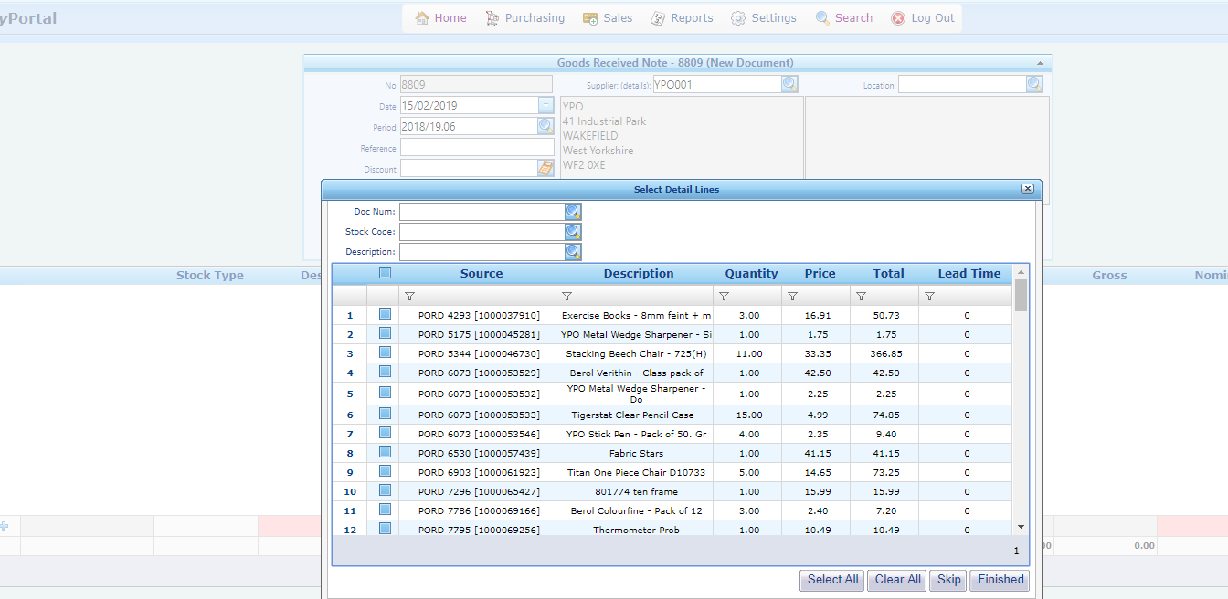

Step 4. Enter the Purchase Order Number you want to Goods Receive items / services for.

You can either select the lines you wish to Goods Receive from this screen by putting a tick next to all the items / services you want to Goods Receive, then selecting finished.

Or you can enter the Purchase Order Number you want to Goods Receive items / services for, which will then bring up a list of the items on the Purchase Order Number only.

Here I have entered the Purchase Order Number 9576 in the Doc Num box and pressed the spyglass , to bring up the 4 lines of Purchase Order Number 9576 which have not yet been Goods Received;

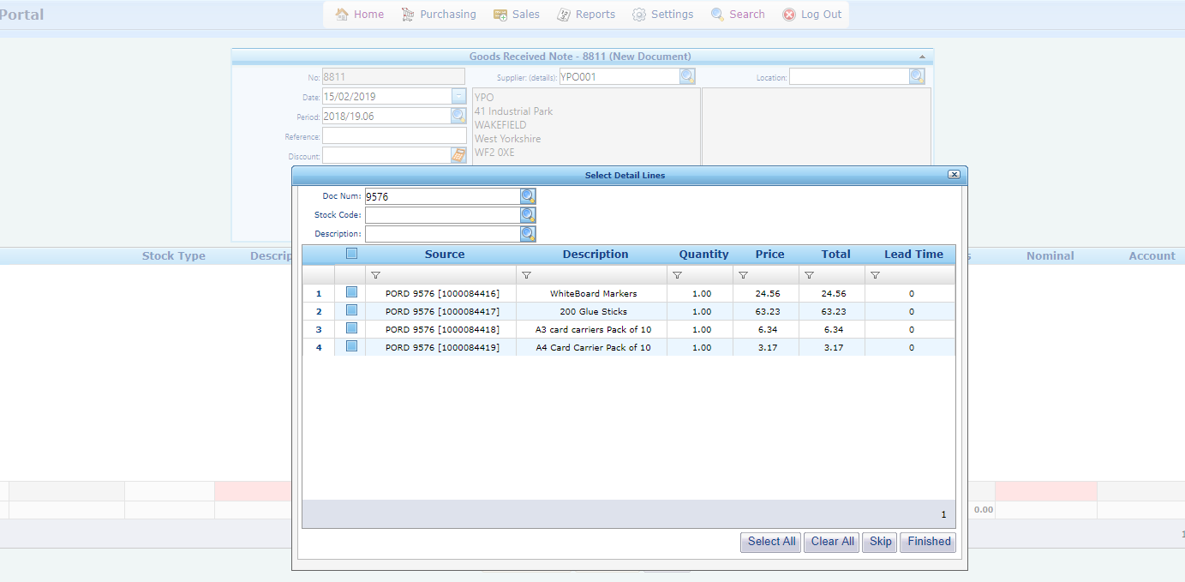
Enter the Purchase Order Number and press the spyglass

Step 5. Select the lines to be Goods Received.
Either tick the box above to select all the items off the Purchase Order, then press finished to enter a Goods Received
Or select the individual lines which need to be Goods Received, then press finished to enter a Goods Received Note;
Important:
If only part of the order has been received only select those items.

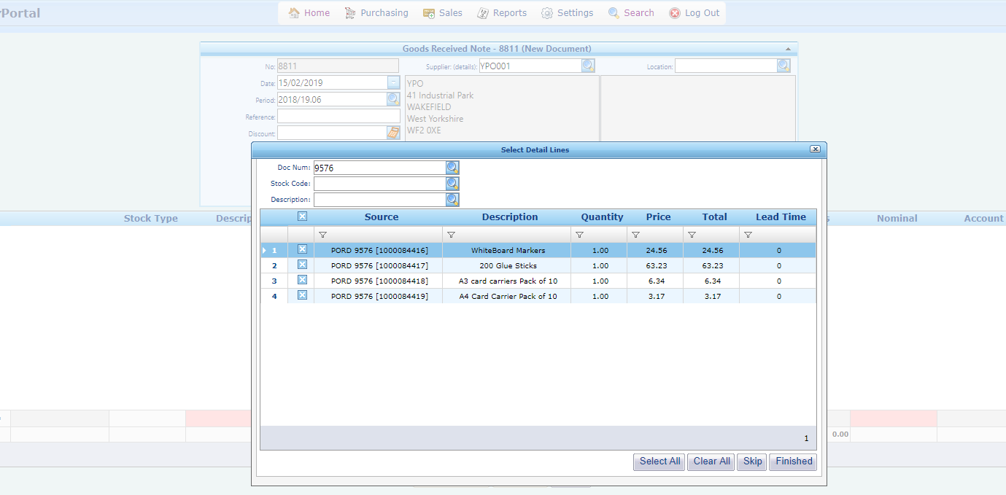
After Selecting items click Finished to enter the Goods Received note
Tick this box to select all items on the Purchase Order
Select individual items to GRN part of the Purchase Order

Step 6. Change any quantities that need changing on the Goods Received Note
This Purchase Order has different quantities of items on each of the lines. If some of the items on a line have not been received yet, the quantity can be reduced here;
Important:
If the full quantity of the items have not been received make sure the quantity is reduced, so we don’t pay for goods we haven’t received.

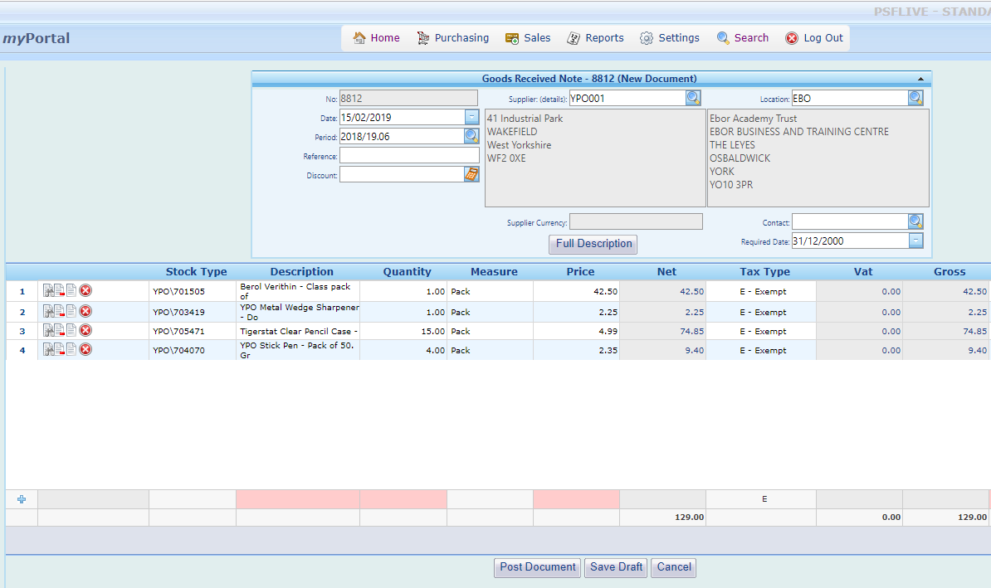
Reduce quantities for any items not received yet

Step 7. Review the Order Details.
Refer any discrepancies (for example: price of items or unexpected postage charges) directly with the Supplier.
Or if you are happy with the quantities received and prices select Post Document to finish the Goods Received Note;
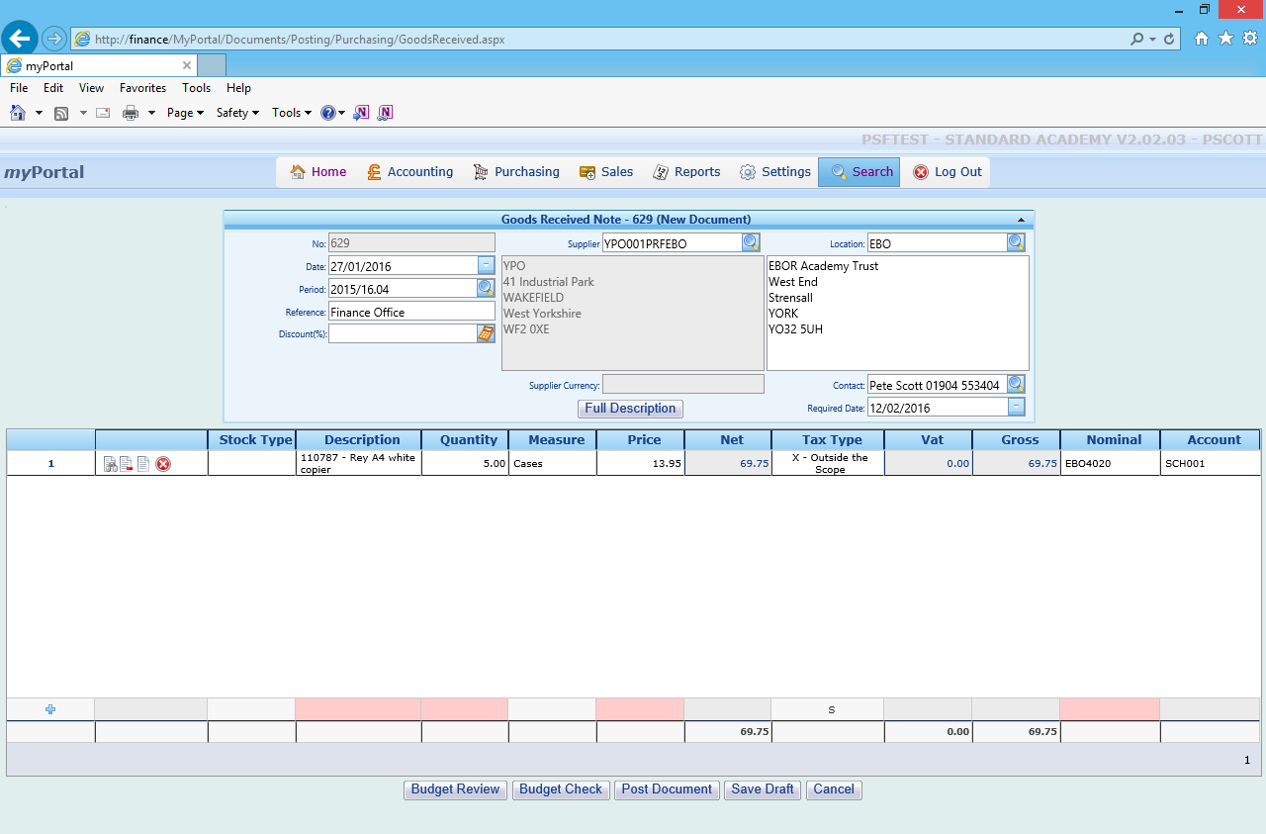
Post Document

Step 8. The Goods Received Note is now complete. Select New Document to Goods Receive other Purchase Orders;
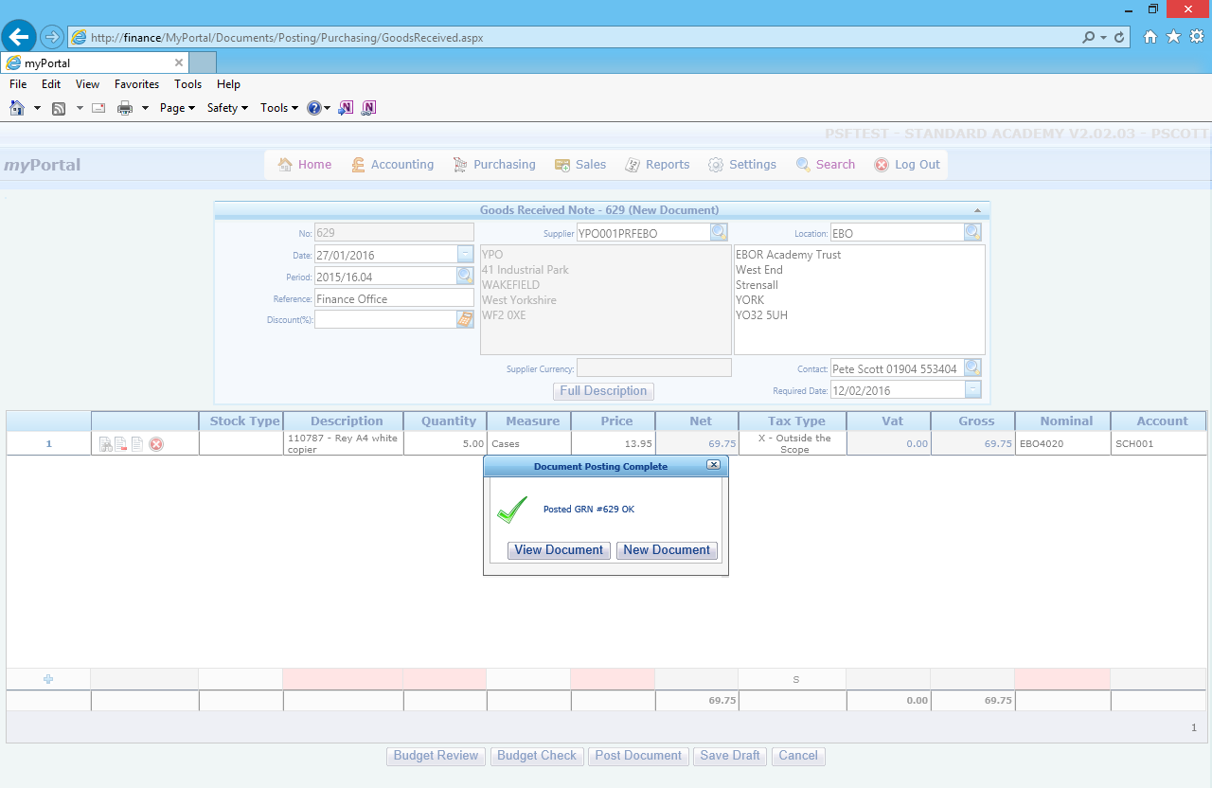
Select New Document to

