Purchasing Document Created 21/02/2019

How to Produce a Purchase Order Version 6.1

Step 1. Select the Purchase Order option
Step 2. Enter the Supplier details
Step 3. Select the Supplier you wish to raise a Purchase Order against
Step 4. Enter a Location
Step 5. Enter a Reference
Step 6. Enter a Contact
Step 7. Enter details of the Order
Step 8. Enter extra lines to an Order
Step 9. Post Document to complete the Purchase Order
Step 10. Sending an Authorised Purchase Order to the supplier

Also included: Saving a Draft Purchase Order

Step 1. Select the Purchase Order option. To do this hover over the Purchasing button;

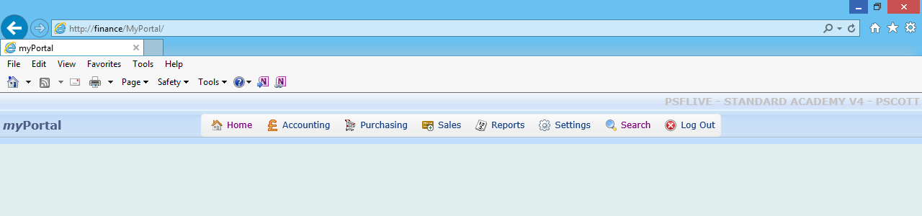
Purchasing button

This dropdown box will appear, then click on Purchase Order;

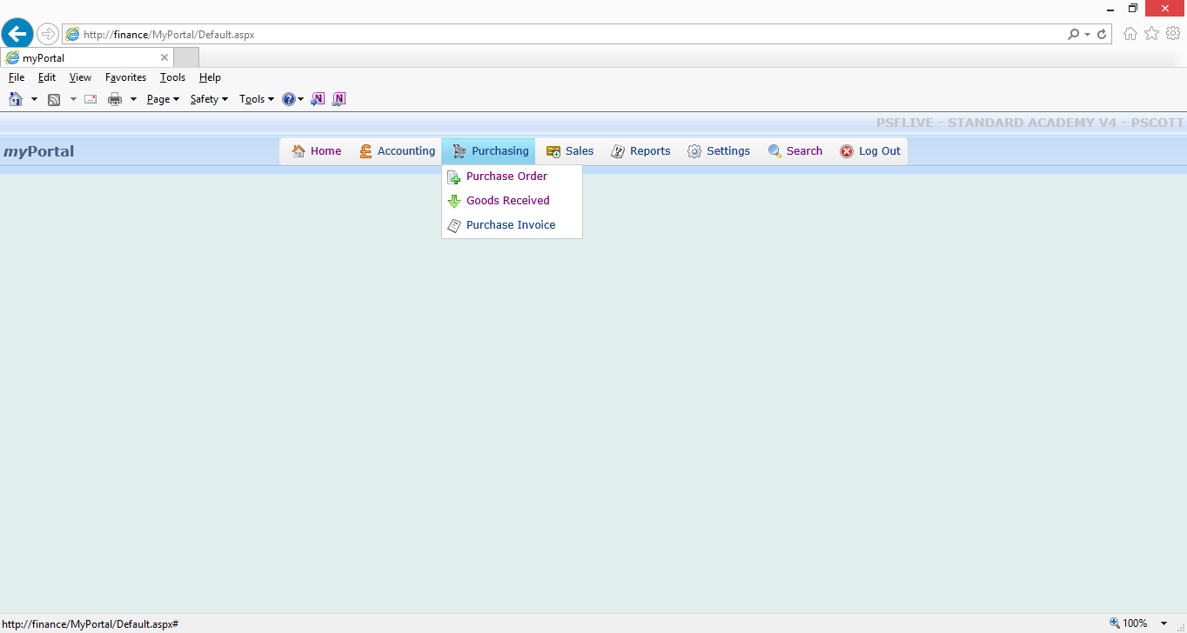
Purchase Order

The Search Supplier screen will appear automatically, as shown below;

Step 2. Enter the Supplier details of the Supplier you want to create a purchase order to.

The example below shows a Purchase Order being created for the supplier name Yorkshire Purchasing Organisation (YPO).
Entering “YPO” in the Supplier box and pressing the spyglass , will bring up all suppliers with a Supplier Account Code starting with YPO (make sure there is no tick in the Suppliers with Requisitions only box);
No tick in this box
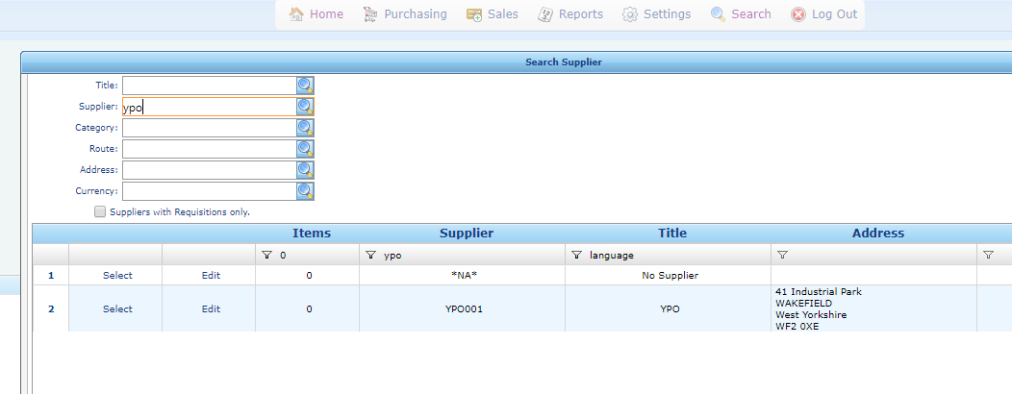
Enter YPO in Supplier

Alternatively, if you do not know the Supplier Account Code, you can search for a word or a part of a word from the supplier title.
Entering “Language” in the title box and pressing the spyglass , as shown below will bring up all suppliers with Language in the Supplier title;

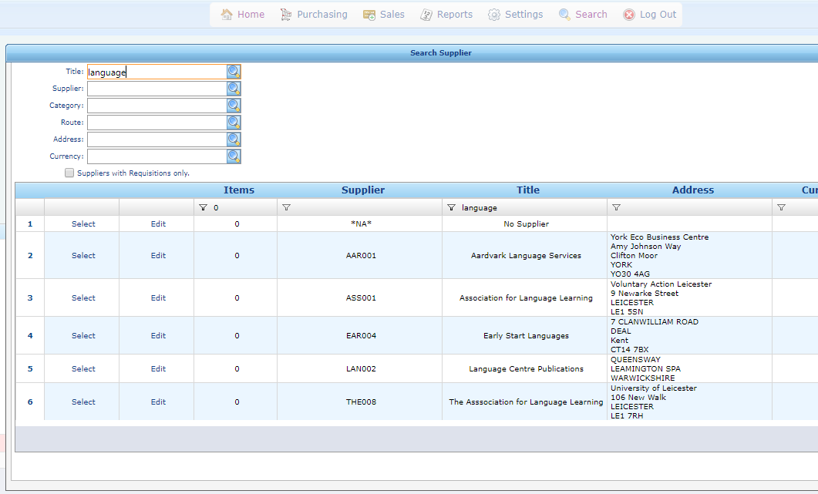
Press Select to start raising a Purchase order against the relevant supplier
Enter Language in Title
No tick in this box

Step 3. Press Select against the supplier you want to raise a Purchase Order for. Shown above here.

The Supplier code and Supplier address are automatically entered into the Purchase Order form, shown below here for YPO;

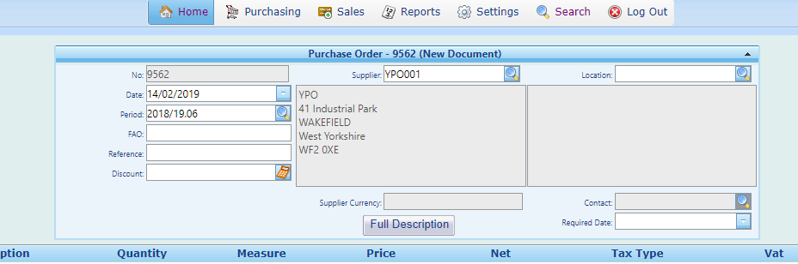
Supplier Code
Supplier address

Step 4. Enter the Location, and press TAB.

The Location field is completed using the 3 letter code for your School e.g. RWS, BBS, FLY etc. If no reference is entered here the supplier could deliver your goods to the invoice address, at Osbaldwick.

Using the TAB key after entering your school Location code automatically loads the Location address. Shown here in this example, for Ebor Academy Trust;

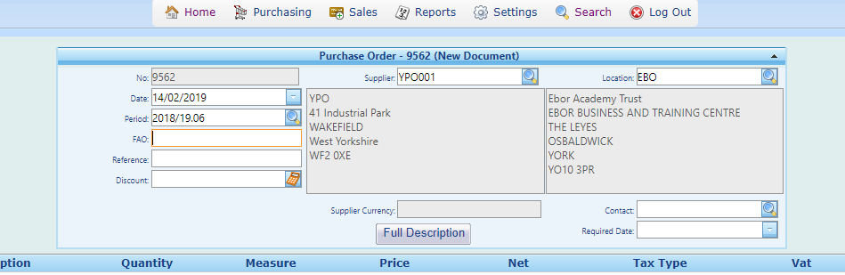
Enter Location code, press TAB

Step 5. Enter a Reference.

The Reference narrative is included on the Purchase Order therefore our recommendation is to use the School Department i.e. School Office/English Dept/Site Team etc.

Here the reference entered is Finance Officer;

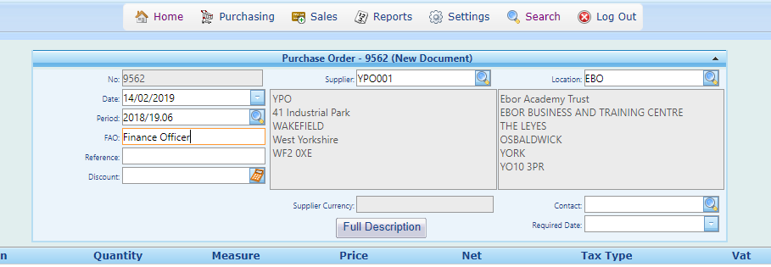
Reference
Step 6. Enter a Contact.

This is the name of the staff member raising the Purchase Order. The Contact name entered will be the initial contact person for any queries or discrepancies relating to the Purchase Order;

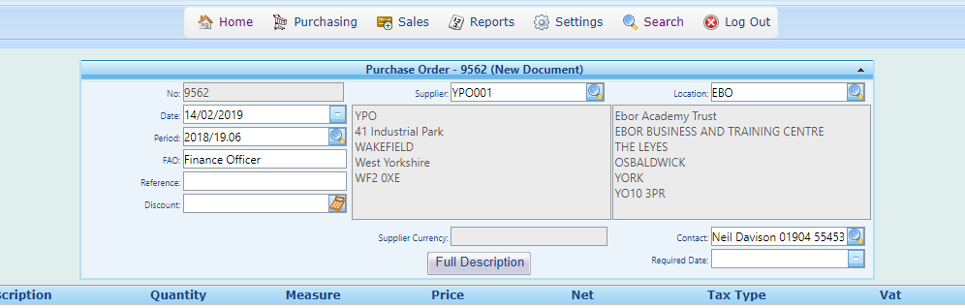
Contact name

Step 7. Enter details of the Purchase Order in the following fields, as listed below;
- Description (Item no. / item description)
- Quantity (Number of items being ordered)
- Measure (Also known as the Unit Value i.e. Box, Pack, Books, Metres etc)
- Price (Per Unit)
- Net (The Net price will automatically calculate)
- Tax Type (All Purchase Orders are X - Outside of the Scope* for VAT)
- VAT (The VAT amount will automatically calculate)
- Gross (The Gross price will automatically calculate)
- Nominal (Nominal code to charge the item to)
- Account (Account code to charge the item to)

*The Tax Type (VAT code) will be corrected when the invoice is processed, where necessary.

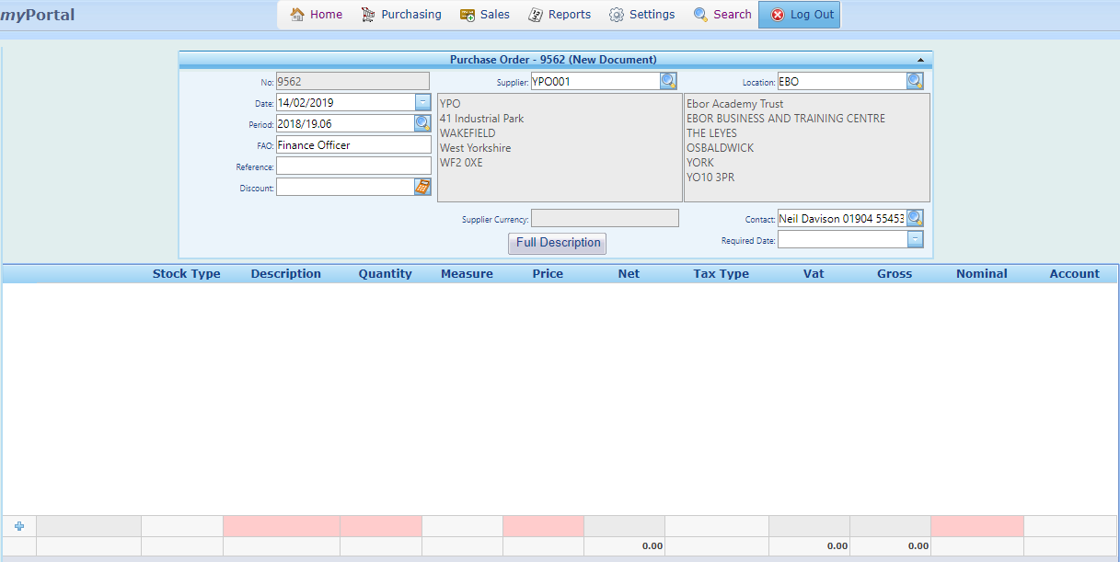
Price
Tax Type
Description
Quantity
Measure
Nominal code
Account code

Once details have been entered in these boxes, press Tab when in the Account Code box to finish adding the line on the Purchase Order.
Purchase Orders must be entered on multiple lines, where appropriate.
This requirement is to ensure invoices linked to Purchase Orders can be paid in a timely manner when goods/ services are received and Commitments remain on the system to track outstanding items still awaiting delivery. Single line entry should no longer be used, unless it is appropriate to do so.

If any boxes that you fill in have a background colour of Orange like the box below, this is either caused by an inputting error, or by entering details you do not have access to, and you should seek advice from the Central Services Finance team;

Step 8. Entering Extra lines to an Order;
Additional lines can be added by filling in the boxes again and pressing Tab to complete the line;
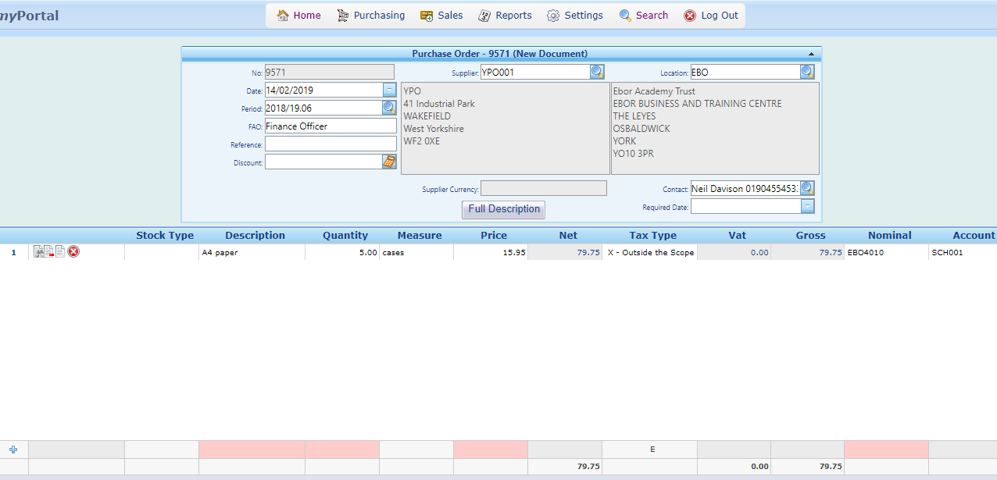
Fill in these boxes again for extra lines on the Purchase Order

If extra lines in any of the boxes have duplicate information from the above line, a full stop can be entered in the relevant box to copy the above detail. Adding a full stop in the Account box will copy “SCH001” from the account box on the above order line, and save typing on those big orders; (For entering Purchase Orders with lots of lines on them, save the Purchase Order regularly by saving as a Draft Purchase Order - see the notes on saving a Draft Purchase Order at the end of this document)

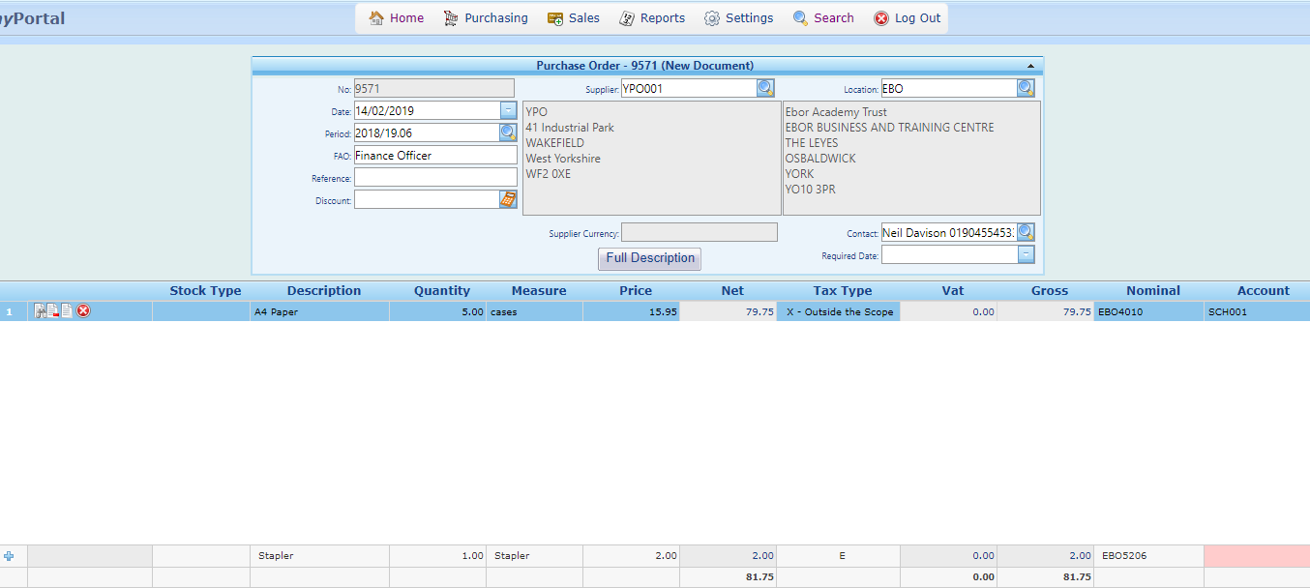
Important:
Please do not add more than 20 lines to a Purchase Order, as orders any larger than this are difficult to process at the invoicing stage
Enter a full stop to copy SCH001 from above

Here I have created an order with 2 lines on it for A4 paper and a stapler. When the Purchase Order has been completed and is ready for submission to the supplier, review all details entered;

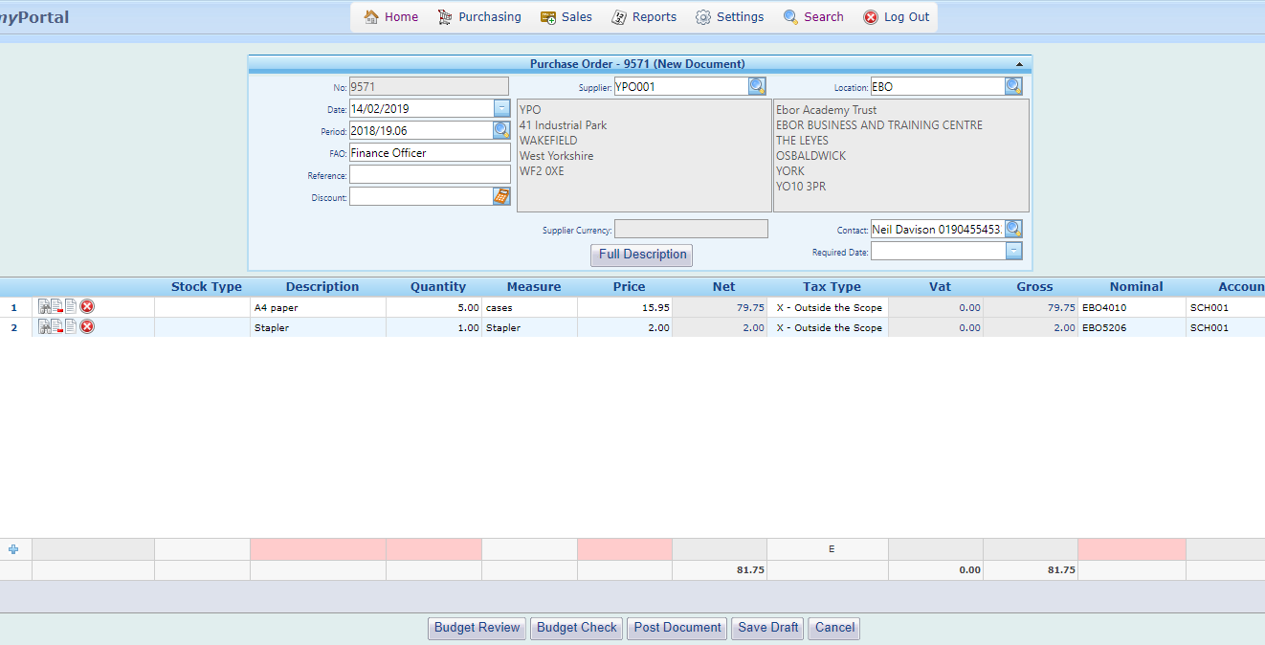

Step 9. Select Post Document to generate the Purchase Order;

Post Document

Once you press the Post Document button a pop-up will appear, which will give the Purchase Order Number for your order;

Important:
The may be higher than the Purchase Order Number that came up when you first started creating the Purchase Order.

If other people in other academies, are creating purchase orders at the same time as you, they will get the next number chronologically if they press Post Document before you.

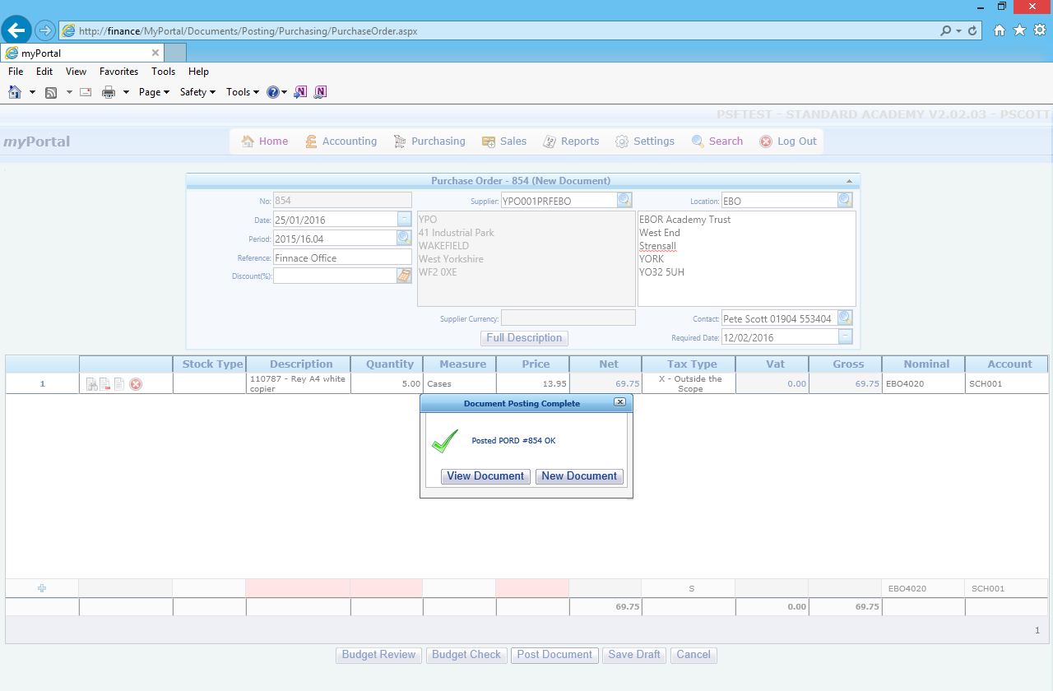
The Purchase Order Number has now been fixed
Your Purchase Order has now been generated, and an email will be sent to the Budget Holder for authorisation. You can now make a note of the Purchase Order Number if this is required for your records.

Important:
Only when the Budget Holder has authorised the Purchase Order does it becomes a Formal Purchase Order that can be submitted to a supplier.

The Budget Holder can now log in to their account to review and authorise the Purchase Order.

Budget Holders should follow the guidance notes How to Authorise a Purchase Order.

Step 10. Once the Purchase Order has been Authorised it can be submitted to the supplier.

The easiest way to submit a Purchase Order is to email it to the supplier as PDF. To generate a PDF of the Authorised Purchase order. To do this first press search on the tool bar. Then enter the Purchase Order Number, in the Document numbers boxes;

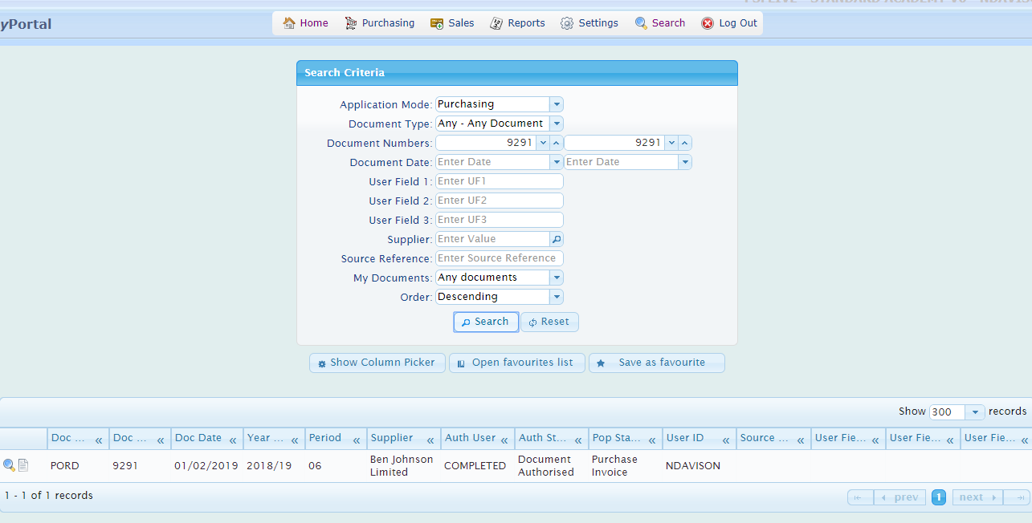
Secondly enter the Document Number
First press Search
Finally press the spyglass

Press the spyglass next to the Purchase Order to go into a view of the Purchase Order;

Then select Reports to load a copy of the Purchase Order that can be submitted to the supplier;

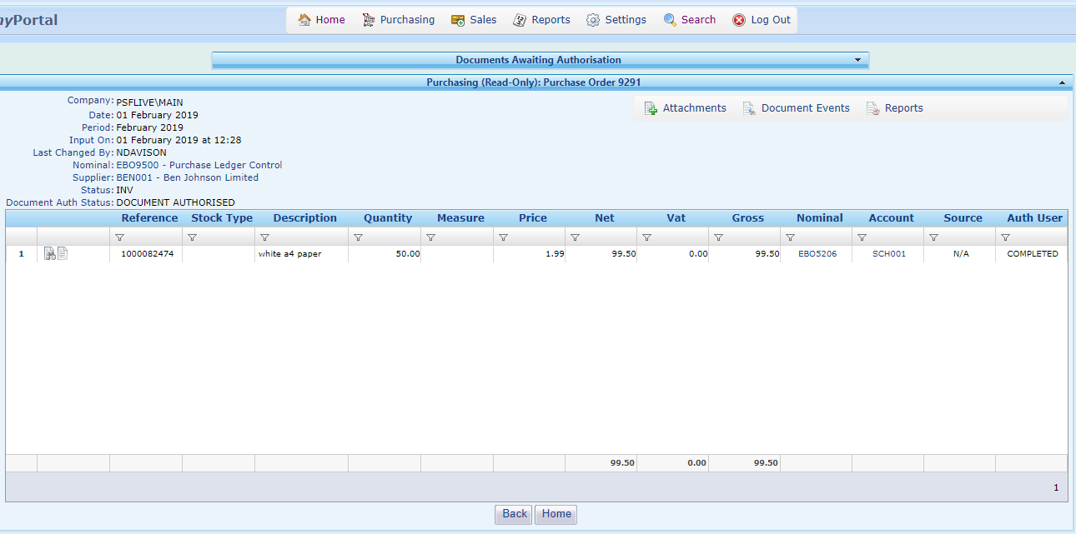
Reports
This is an example of a Purchase Order. If you click on the disc symbol, then select PDF this will generate a PDF, that can be attached to an email to the supplier, to place the order;

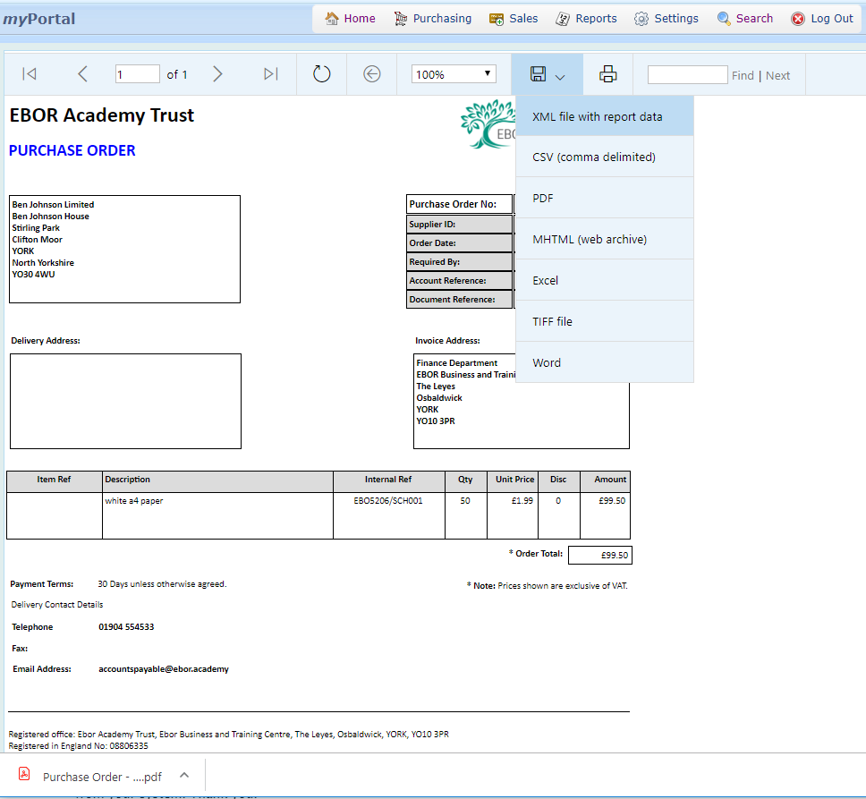
PDF ready to attach to an email
Click on the disc then select PDF

Draft Purchase Orders

Purchase Orders can be saved as a Draft (Save Draft) for amending or adding to at a later date, up until you are ready to submitting the Purchase Order to the supplier. If you have added multiple lines to a Purchase Order or you are interrupted, it is advisable to save the Purchase Order as a Draft to save your work;
Important:
Please do not add more than 20 lines to a Purchase Order, as orders any larger than this are difficult to process at the invoicing stage

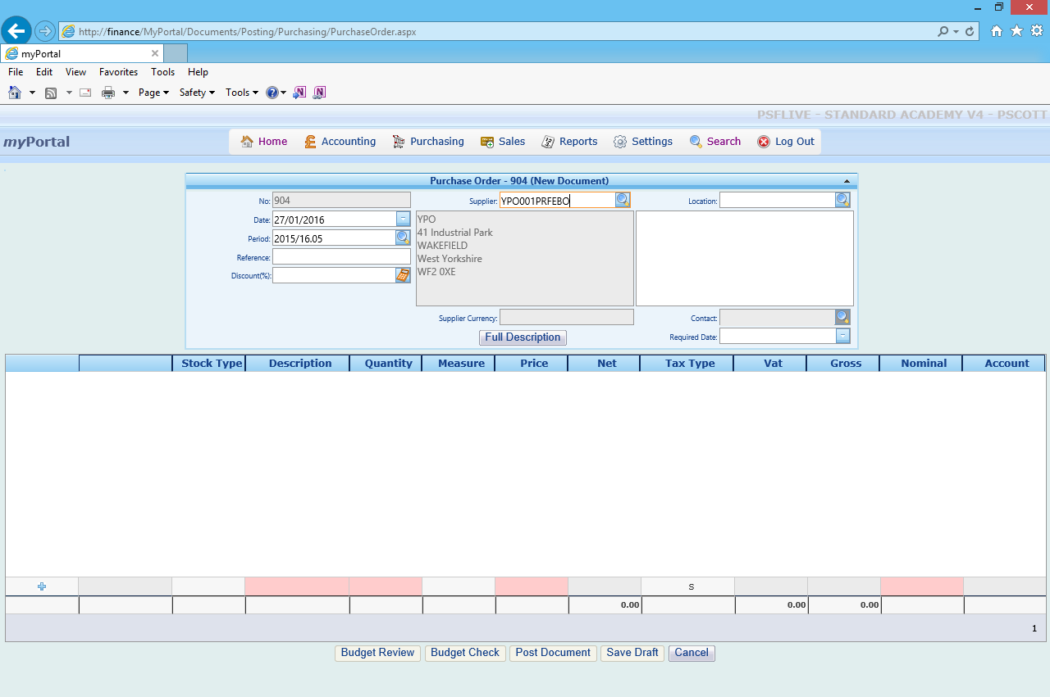
Save Draft

Saved Drafts can be found through the Search option, shown below then filling in these boxes as follows:

- In Document Type enter: PORD - Purchase Order
- In My Documents enter: Drafts

Then Press Search on the Search Criteria screen;

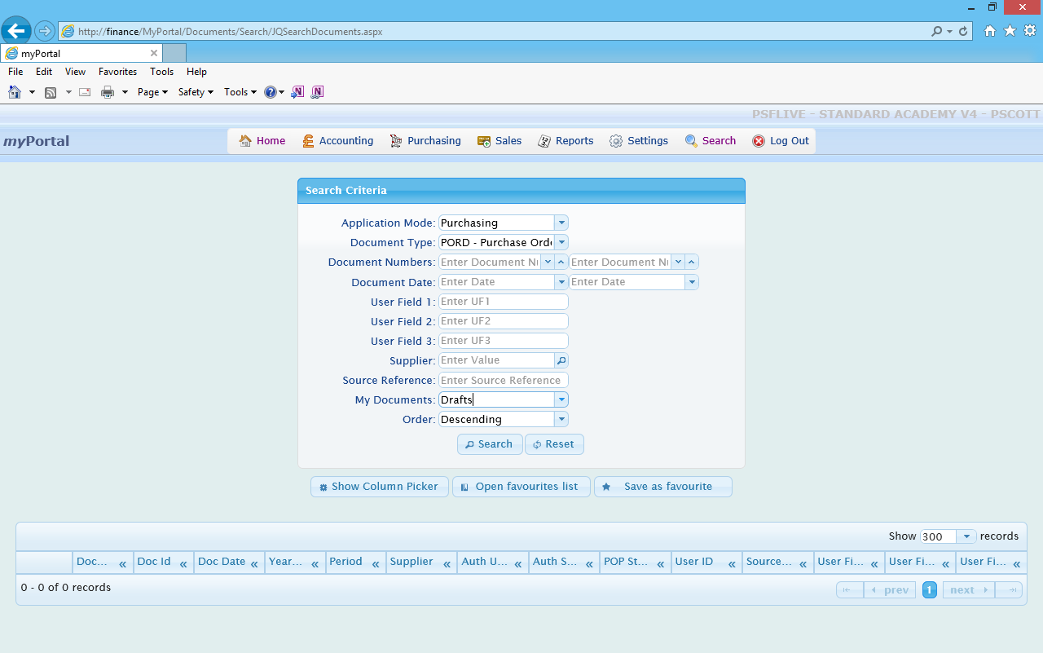
Finally select Search
First select Search
Select PORD – Purchase Order
Select - Drafts

After searching for Drafts, a list of all Drafts created across all our academies will appear. Simply select the Draft you want to use, by clicking on the spyglass ,and you will be able to resume working on the Purchase Order;

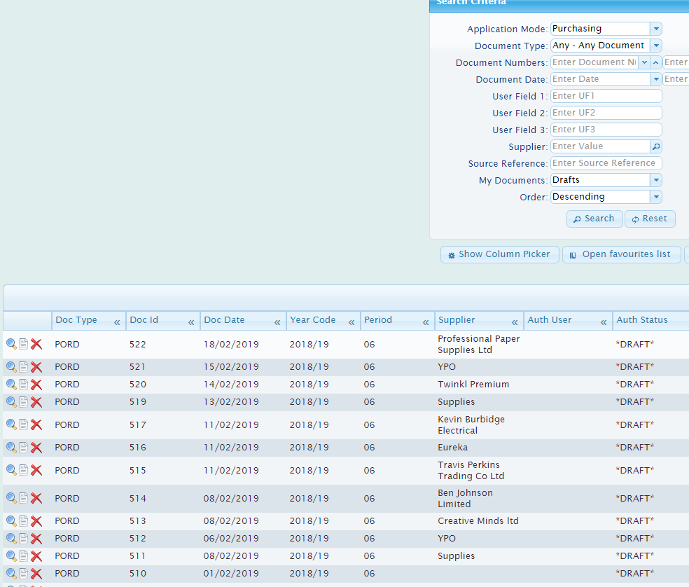
Select to resume working on the Purchase Order

Once you have placed the Purchase Order with the supplier, you can keep the Draft version for use again, in the future. (However anyone from any Ebor Academy Trust Academies can view the list of Drafts)

You can also delete a Draft Purchase Order by clicking on the red cross next to the Draft document on the list of Drafts;

Select to delete the Draft

