Purchasing Document Created 21/02/2019

Ad Hoc Payment Request Form Version 6.1

Step 1. When is an Ad Hoc Payment Request Required?
Step 2. Finding an Ad Hoc Payment Request Form
Step 3. Filling out an Ad Hoc Payment Request Form

Step 1. When is an Ad Hoc Payment Request Required?

An Ad Hoc Payment Request Form is required when your school wants to make a one off payment, for goods or services, and further services will not be required from the supplier again. This will allow us to make a one off payment to the supplier, without having the supplier entered on PS Financials (we will not need a new supplier form before we make a payment).

Step 2. Finding an Ad Hoc Payment Request Form.
The Ad Hoc Payment Request Form is located on the Ebor Academy Trust website under the Staff resources tab at the bottom of the page. After clicking here, click on the Finance Tab, and you will be taken to a list of finance documents, the Ad Hoc Payment Request form is about a third of the way down the list of finance forms. Click on the template to download an editable version of the form in Excel;

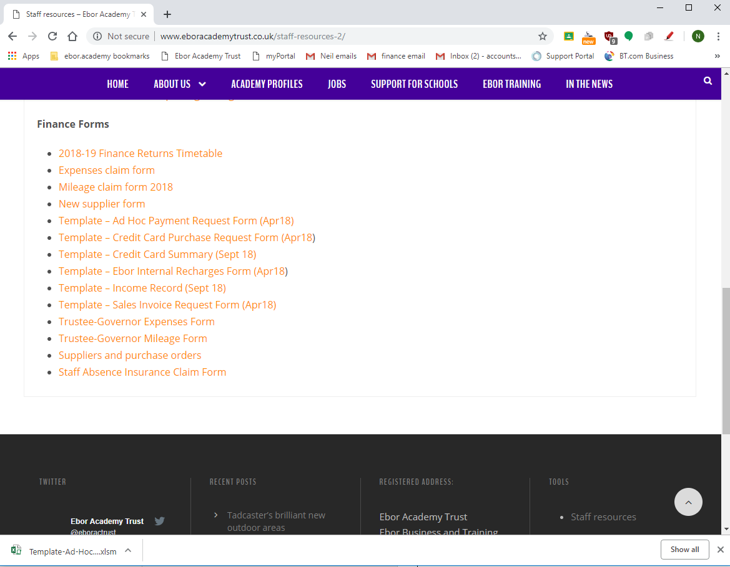
Excel Version of Ad Hoc Payment Request Form
Ad Hoc Payment Request Form
Staff resources tab

Step 3. Filling out an Ad Hoc Payment Request Form.

Here is a copy of the Ad Hoc Payment Request Form;

The Enable Editing button will need to be clicked on before you can edit or save a version of the form.

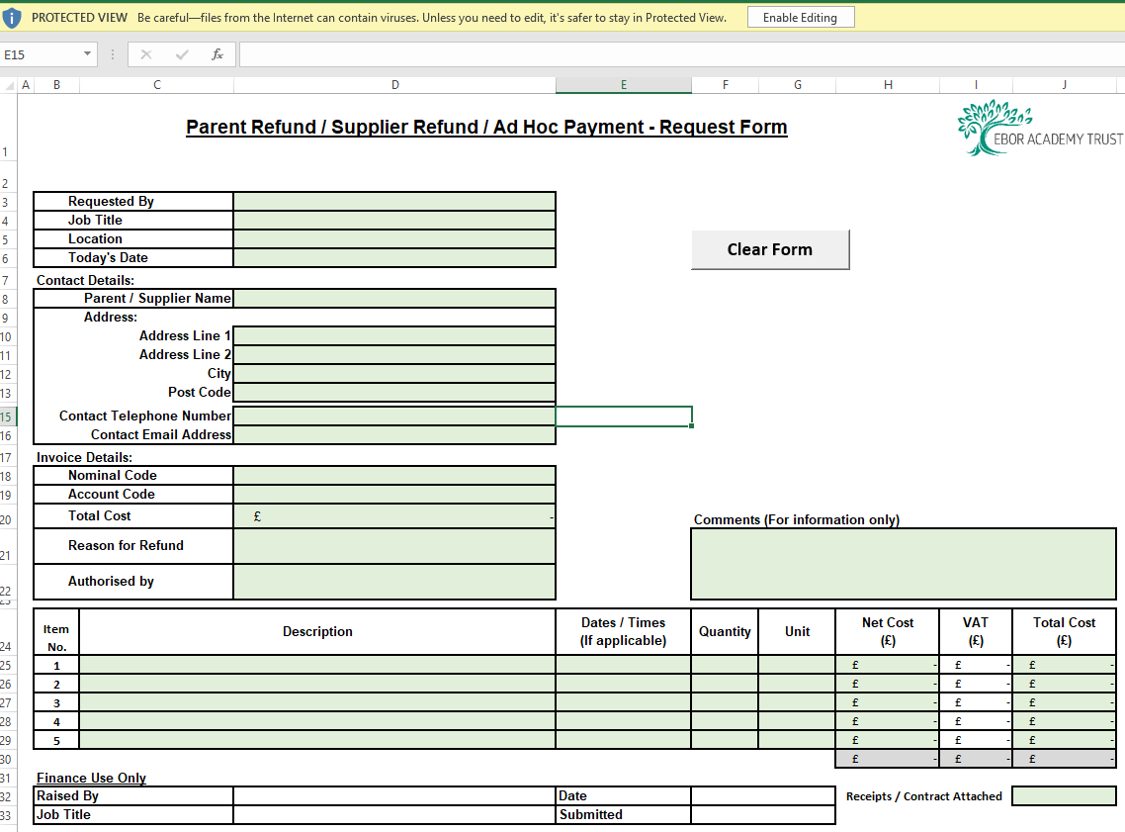
Enable Editing tab

Once you have a version of the form you can edit I recommend saving a copy somewhere safe for future use.

Then fill out the form with all the relevant boxes filled in, any missing information will slow down the processing of the form, as we will have to request information from you.

Once you have filled in as much of the form as you can, print this form out and obtain a signature from the budget holder, to go in the Authorised by box next to their name, and scan the form to the finance email address so we can process this for payment;

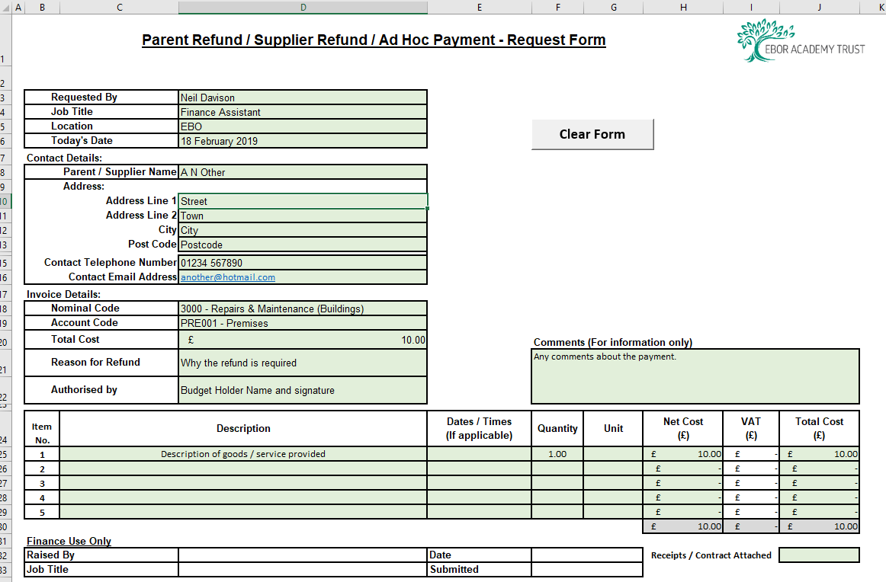
Drop down boxes to fill in
Print off and obtain signature
Important:
Any forms sent to us without a valid Budget Holder’s signature will be returned to obtain a signature.

